Test Case: tc001_SPX_Dev5_Crear_Nueva_Linea_Requisicion_Spot_Tipo_Cobro_CC
Step 1 - Enter username and password and click to button Enter : Credentials Entered
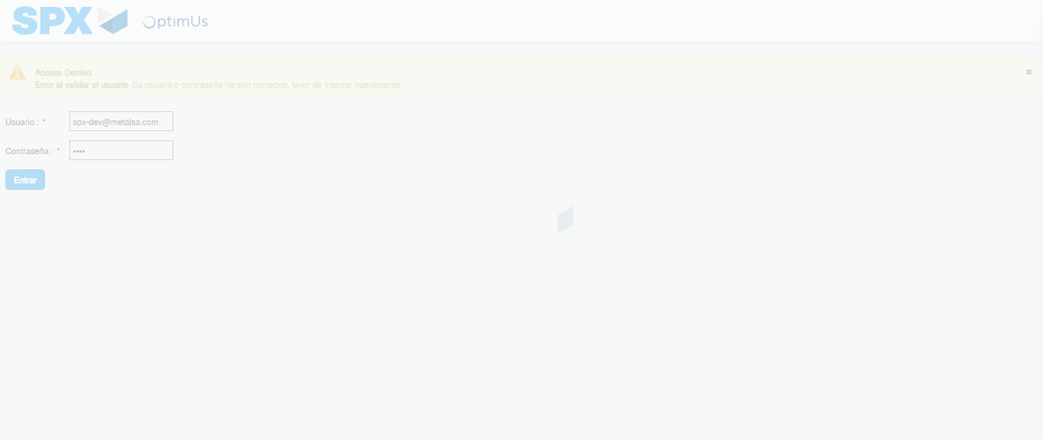Image file-name: QC_Testing-tc001_SPX_Dev5_Crear_Nueva_Linea_Requisicion_Spot_Tipo_Cobro_CC-1790176984380

Step 2 - Select to UEN and Access to Spot Buy Requisitions : UEN Correctly selected and Correct access
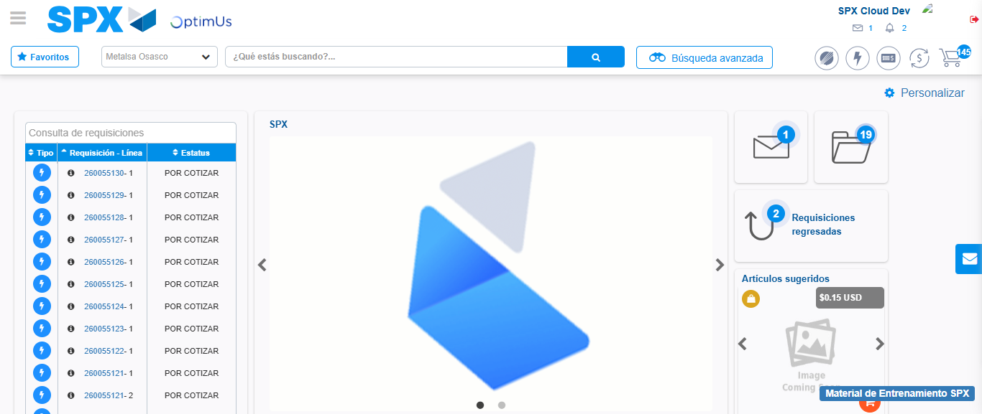Image file-name: QC_Testing-tc001_SPX_Dev5_Crear_Nueva_Linea_Requisicion_Spot_Tipo_Cobro_CC-1790177007730

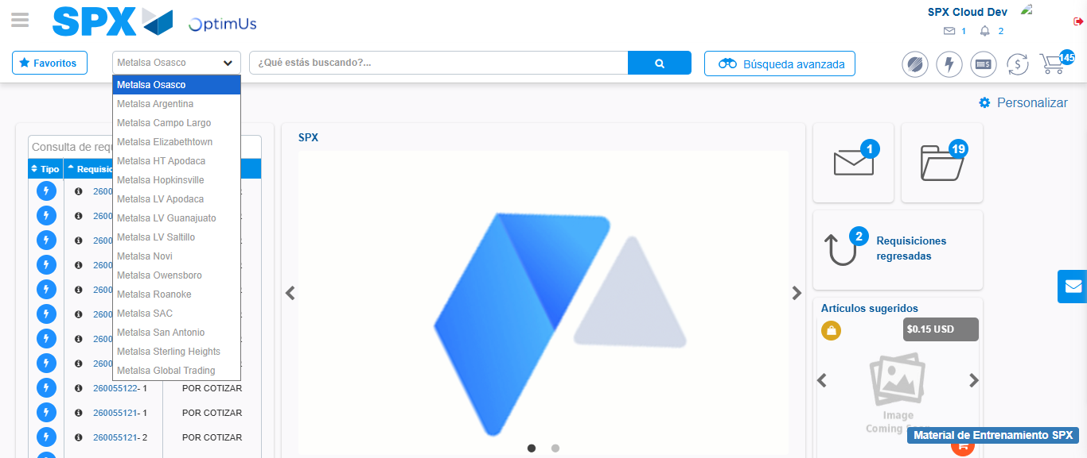Image file-name: QC_Testing-tc001_SPX_Dev5_Crear_Nueva_Linea_Requisicion_Spot_Tipo_Cobro_CC-1790177008238

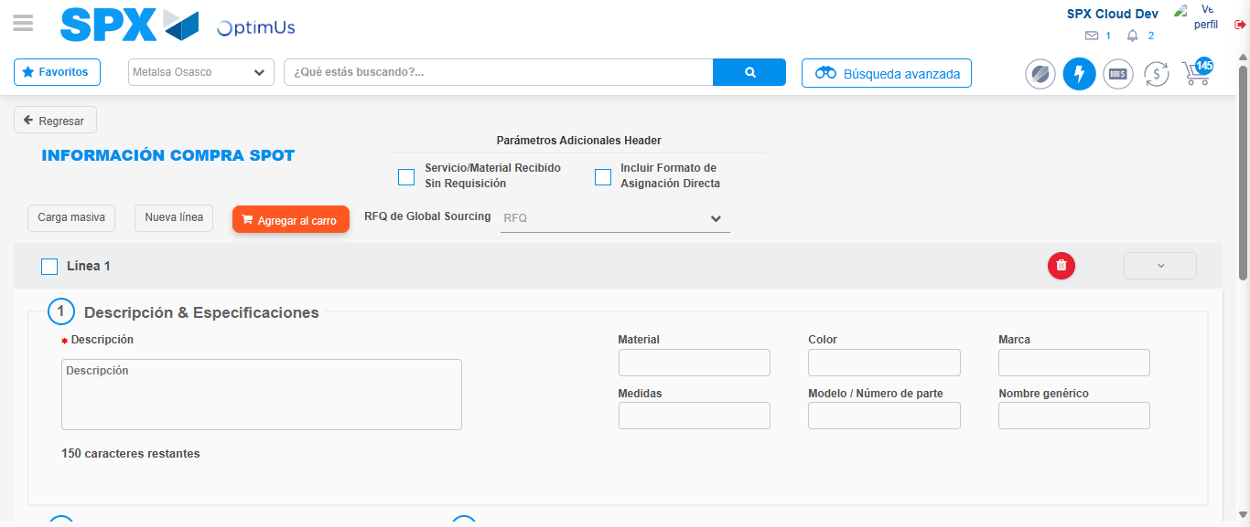Image file-name: QC_Testing-tc001_SPX_Dev5_Crear_Nueva_Linea_Requisicion_Spot_Tipo_Cobro_CC-1790177013456

Step 3 - Data Capture Spot Buy Requisition: Data captured correctly
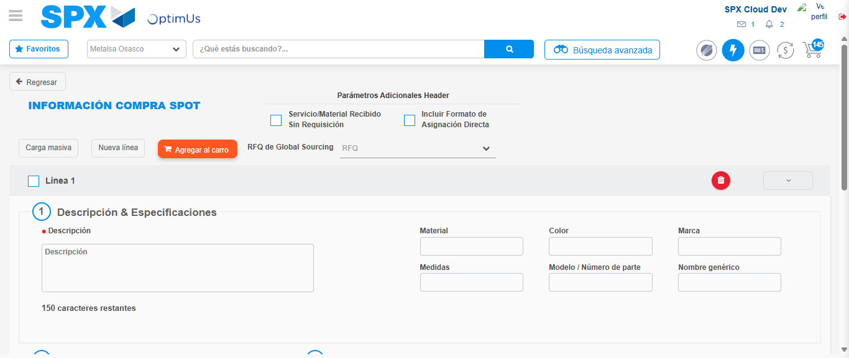Image file-name: QC_Testing-tc001_SPX_Dev5_Crear_Nueva_Linea_Requisicion_Spot_Tipo_Cobro_CC-1790177013683

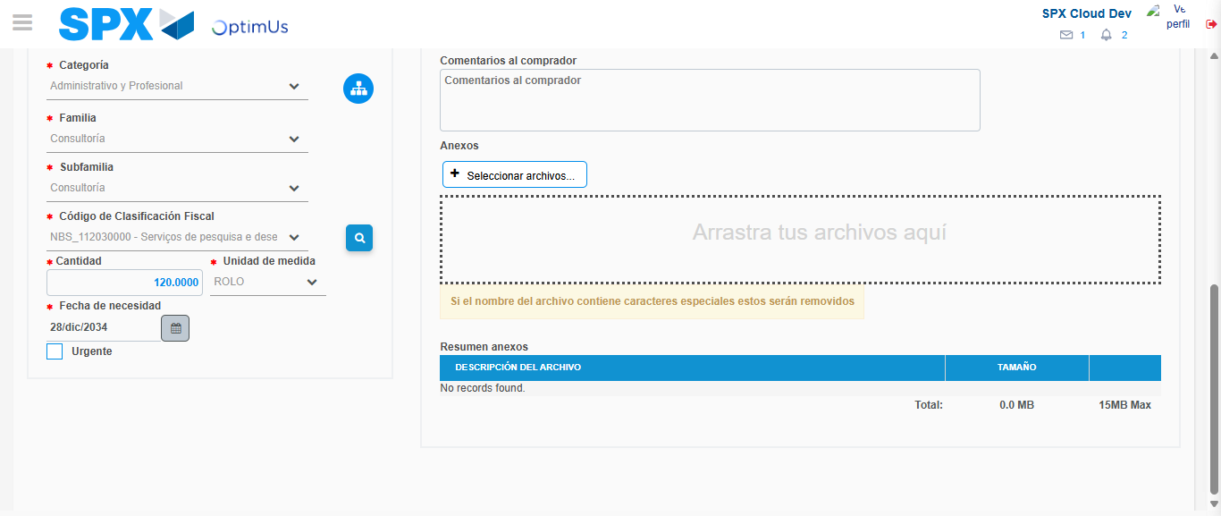Image file-name: QC_Testing-tc001_SPX_Dev5_Crear_Nueva_Linea_Requisicion_Spot_Tipo_Cobro_CC-1790177038780

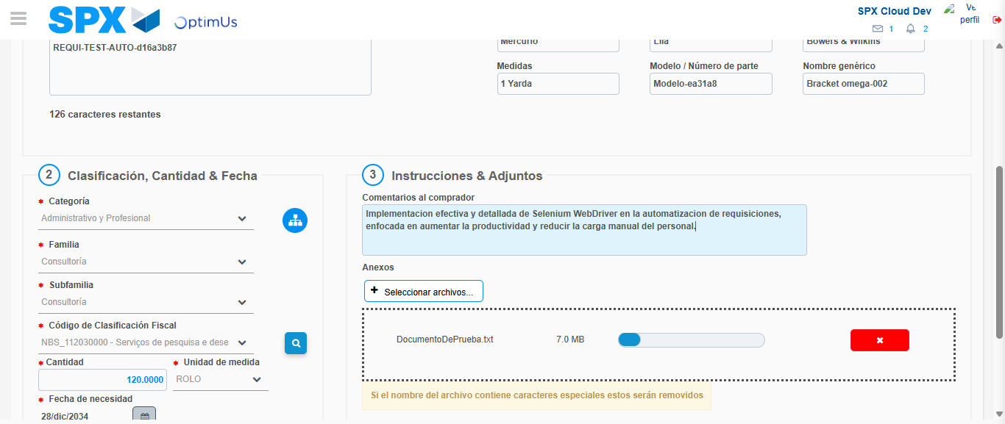Image file-name: QC_Testing-tc001_SPX_Dev5_Crear_Nueva_Linea_Requisicion_Spot_Tipo_Cobro_CC-1790177039858

Step 4 - Add new line and data capture second line: Line add correctly
Image file-name: QC_Testing-tc001_SPX_Dev5_Crear_Nueva_Linea_Requisicion_Spot_Tipo_Cobro_CC-1790177013683

Image file-name: QC_Testing-tc001_SPX_Dev5_Crear_Nueva_Linea_Requisicion_Spot_Tipo_Cobro_CC-1790177038780

Image file-name: QC_Testing-tc001_SPX_Dev5_Crear_Nueva_Linea_Requisicion_Spot_Tipo_Cobro_CC-1790177039858

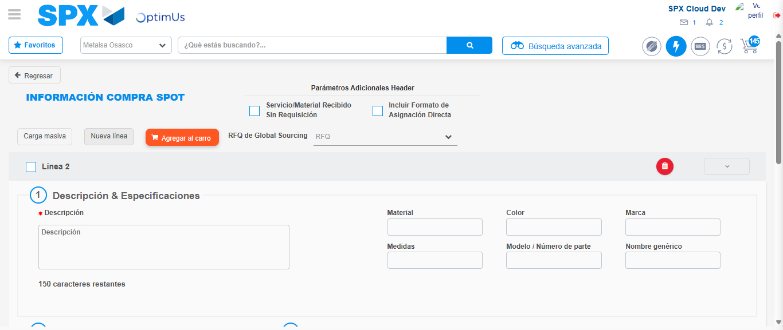Image file-name: QC_Testing-tc001_SPX_Dev5_Crear_Nueva_Linea_Requisicion_Spot_Tipo_Cobro_CC-1790177042225

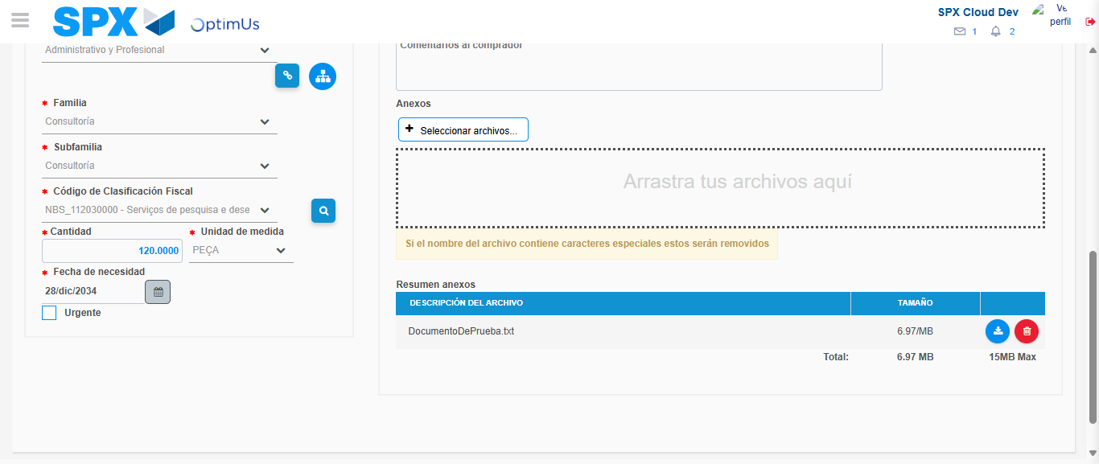Image file-name: QC_Testing-tc001_SPX_Dev5_Crear_Nueva_Linea_Requisicion_Spot_Tipo_Cobro_CC-1790177060618

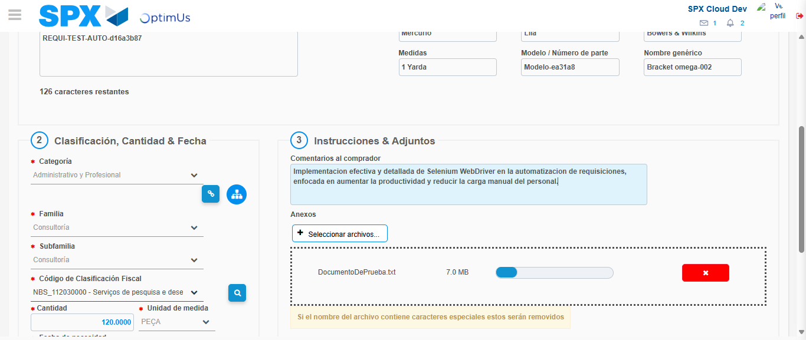Image file-name: QC_Testing-tc001_SPX_Dev5_Crear_Nueva_Linea_Requisicion_Spot_Tipo_Cobro_CC-1790177061517

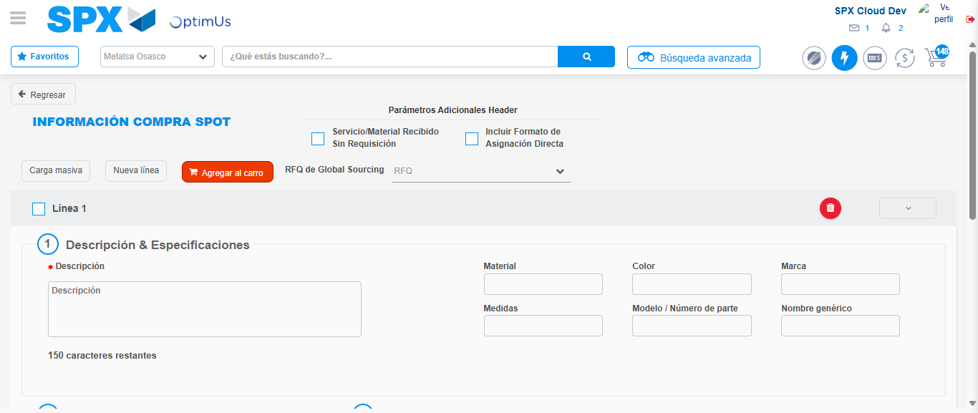Image file-name: QC_Testing-tc001_SPX_Dev5_Crear_Nueva_Linea_Requisicion_Spot_Tipo_Cobro_CC-1790177077096

Step 8 - Return to Main Page SPX : Return to Main Page SPX
Image file-name: QC_Testing-tc001_SPX_Dev5_Crear_Nueva_Linea_Requisicion_Spot_Tipo_Cobro_CC-1790177007730

Image file-name: QC_Testing-tc001_SPX_Dev5_Crear_Nueva_Linea_Requisicion_Spot_Tipo_Cobro_CC-1790177008238

Image file-name: QC_Testing-tc001_SPX_Dev5_Crear_Nueva_Linea_Requisicion_Spot_Tipo_Cobro_CC-1790177013456

Image file-name: QC_Testing-tc001_SPX_Dev5_Crear_Nueva_Linea_Requisicion_Spot_Tipo_Cobro_CC-1790177079413

Image file-name: QC_Testing-tc001_SPX_Dev5_Crear_Nueva_Linea_Requisicion_Spot_Tipo_Cobro_CC-1790177079640

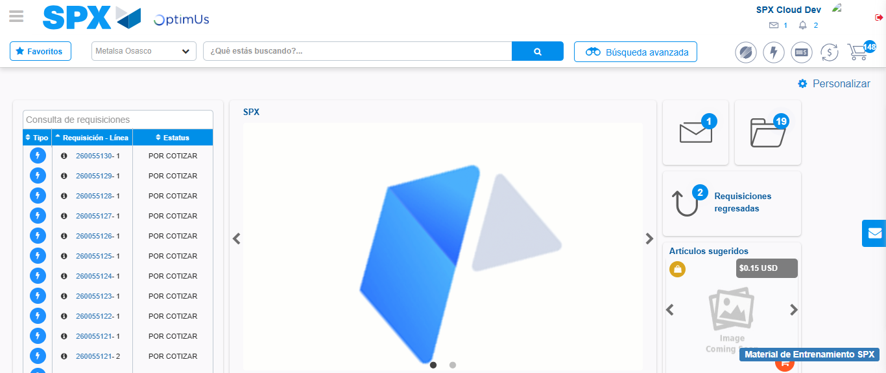Image file-name: QC_Testing-tc001_SPX_Dev5_Crear_Nueva_Linea_Requisicion_Spot_Tipo_Cobro_CC-1790177101221

Step 9 - Log Out : Log Out SPX
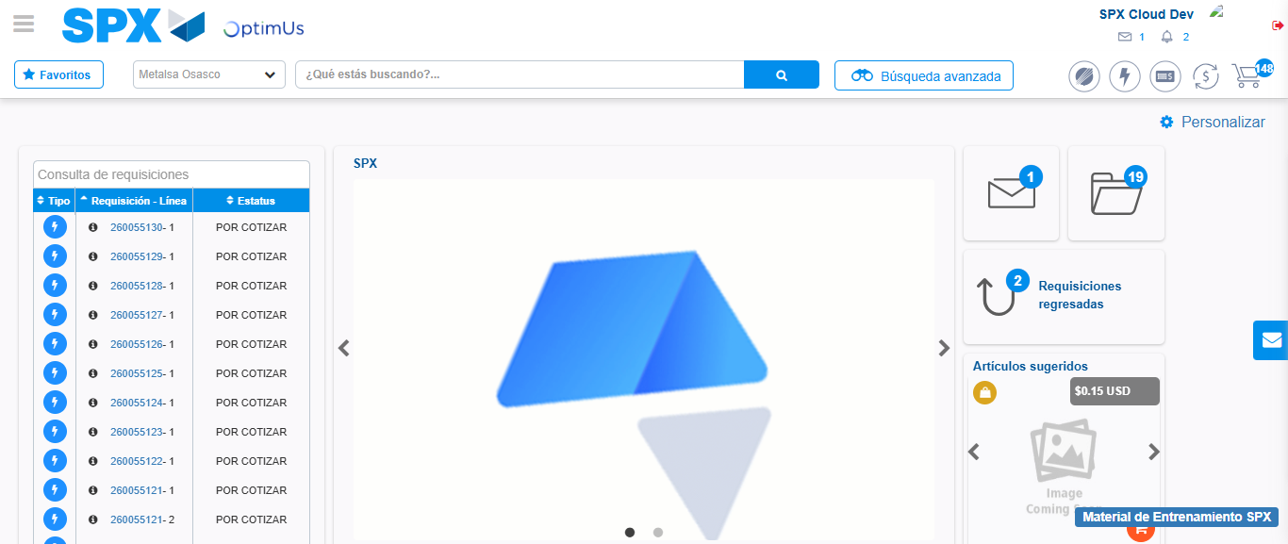Image file-name: QC_Testing-tc001_SPX_Dev5_Crear_Nueva_Linea_Requisicion_Spot_Tipo_Cobro_CC-1790177101602

